ALUMINIUM PRODUCT
ALUMINIUM PRODUCT

Aluminium Flat Bar Gratings
Aluminium flat bar gratings are a proven and traditional grating solution, engineered for strength, durability, and lightweight performance. These gratings can be manufactured in multiple configurations, including flat load bars combined with flat or round cross bars, and a wide range of mesh sizes to suit different structural and architectural requirements.
Each grating is custom-designed and fabricated to meet our customers’ specific load, span, and application needs.
https://www.hygrating.com/wp-content/uploads/2025/02/3abf66cfaefc67ac0d438e9b42ff942e-1024x666-1.jpg
https://www.hygrating.com/wp-content/uploads/2025/02/Serrated-bar-grating-4-2048x2048.jpg
https://www.hygrating.com/wp-content/uploads/2025/02/Serrated-bar-grating-3-2048x2048.jpg
https://www.hygrating.com/wp-content/uploads/2025/02/Serrated-bar-grating-2-2048x2048.jpg

Material Finish
- Aluminium Mill Finish
- Pickled
- Anodised
- Powder Coated
Material Grades
- EN AW 6060
- EN AW 6063 T6
- EN AW 6082 T6
Flat Type
- Plain
- Mechanically Serrated (Anti-Slip)
Load Bar (Bearing Bar)
- Height: 20 mm to 50 mm
- Thickness: 2 mm to 6 mm
Cross Bar (Traverse Bar)
- 10 × 3 mm
- 12 × 3 mm
Mesh Sizes (Pitch)
- 30 × 50 mm, 30 × 100 mm
- 40 × 50 mm, 40 × 100 mm
- 13.5 × 100 mm
- 17.5 × 50 mm, 17.5 × 100 mm
- 35 × 50 mm, 35 × 100 mm

Applications
- Industrial walkways and platforms
- Trenches and drainage covers
- Stair treads and catwalks
- Fencing and safety barriers
- Building facades and architectural screens
- Pontoons and marine structures
- Window sunshades
- Air-conditioning grills and louvers

Key Advantages
- Lightweight yet high load-bearing capacity
- Excellent corrosion resistance, ideal for coastal and industrial environments
- Low maintenance and long service life
- Easy handling and installation
- Attractive architectural appearance
- Customizable sizes, finishes, and load ratings

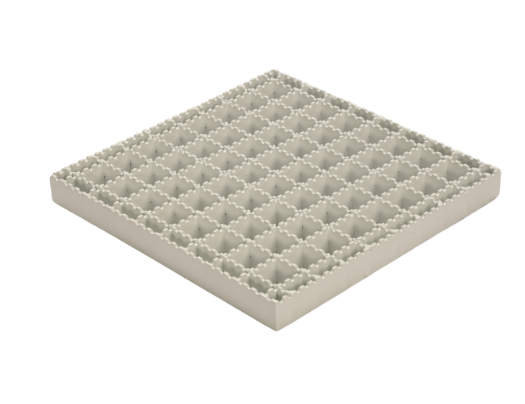
- ALUMINUM SERRATED GRATING
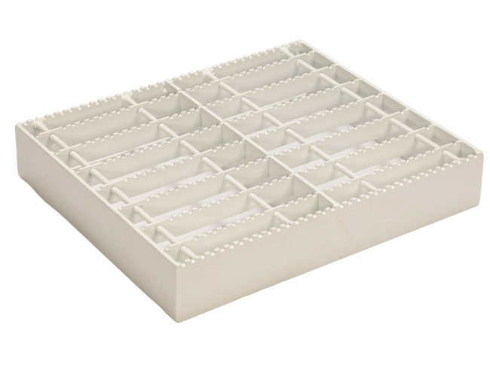
- ALUMINIUM FACADE CATWALK
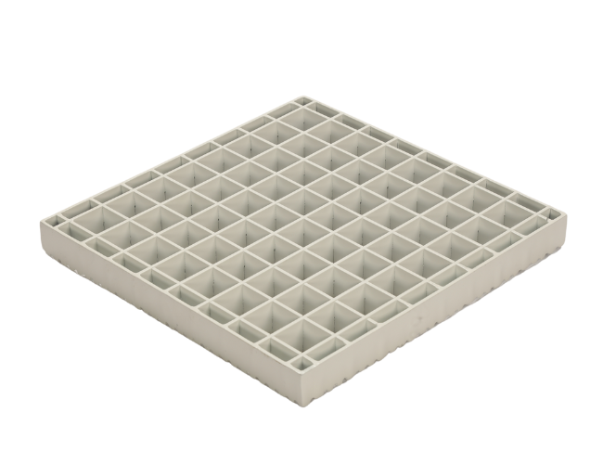
ALUMINUM PLAIN GRATING
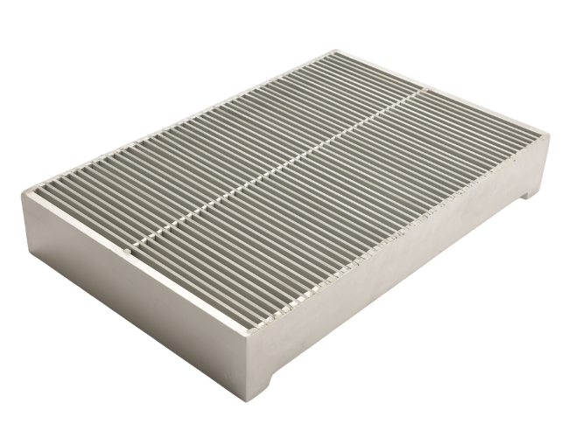

ALUMINUM HEELPROOF GRATING

Aluminum Swaged Gratings
Aluminum Swaged Gratings
Aluminum Swaged Gratings are manufactured without welding between the load bars and cross bars. Instead, the cross bars are hydraulically swaged under high pressure into pre-punched load bars, creating a permanent mechanical bond.
This advanced swaging process ensures exceptional structural integrity, uniform appearance, and long-term durability.
Aluminum swaged gratings are supplied in standard panels as well as tailor-made sizes, precisely engineered to meet project-specific load and span requirements.
https://www.hygrating.com/wp-content/uploads/2025/02/1-20112Q40450-1.jpg
https://www.hygrating.com/wp-content/uploads/2025/02/1-1.gif
https://www.hygrating.com/wp-content/uploads/2025/02/1-20112Q40450-1.jpg
https://www.hygrating.com/wp-content/uploads/2025/02/7f7b7a295052b5f825933ebbee6f2da6-1024x768-1.jpg
https://www.hygrating.com/wp-content/uploads/2025/02/7f7b7a295052b5f825933ebbee6f2da6-1024x768-1.jpg
https://www.hygrating.com/wp-content/uploads/2025/02/02d225b23b90cd41a5e49b4205d54226-2-1.jpg

Standard Panel Sizes
- 6000 × 1000 mm
- 3000 × 1000 mm
Custom panel sizes available on request.

Material Finish
- Aluminium Mill Finish
- Pickled
- Anodised
- Powder Coated
Material Grades
- EN AW 6060
- EN AW 6063 T6
- EN AW 6082 T6
Flat Type
- Plain
- Mechanically Serrated (Anti-Slip)
Load Bar (Bearing Bar)
- Height: 20 mm to 50 mm
- Thickness: 2 mm to 6 mm
Cross Bar (Traverse Bar)
- 10 × 3 mm
- 12 × 3 mm
Mesh Sizes (Pitch)
- 30 × 50 mm, 30 × 100 mm
- 40 × 50 mm, 40 × 100 mm
- 13.5 × 100 mm
- 17.5 × 50 mm, 17.5 × 100 mm
- 35 × 50 mm, 35 × 100 mm

Applications
- Industrial walkways and platforms
- Trenches and drainage covers
- Stair treads and catwalks
- Fencing and safety barriers
- Building facades and architectural screens
- Pontoons and marine structures
- Window sunshades and louvers
- Air-conditioning grills
- Curtain wall systems

Key Advantages
- No welding – eliminates heat-affected zones and weld failures
- High strength-to-weight ratio
- Excellent corrosion resistance, ideal for coastal and chemical environments
- Uniform load distribution and superior rigidity
- Clean, precise appearance for architectural applications
- Low maintenance and long service life
- Easy installation and handling

T & I Bar Gratings
T & I Bar Gratings
T & I Bar Gratings are manufactured using extruded aluminium bearing bars in T-shaped and I-shaped profiles, offering superior strength, rigidity, and a high strength-to-weight ratio.
In this grating system, the cross bars pass through the center of the load bars, forming a strong interlocked structure without welding, ensuring long-term durability and dimensional accuracy.
These gratings are ideal for industrial, marine, and architectural applications, where lightweight, corrosion resistance, and clean appearance are essential.

https://www.hygrating.com/wp-content/uploads/2025/02/215f883be1321b5e83e0a5bebe1ad003-3-1024x768-1-1.jpg
https://www.hygrating.com/wp-content/uploads/2025/02/2-1.gif
https://www.hygrating.com/wp-content/uploads/2025/02/6d8923e7f540851d98b924cc7ebd093e-1024x768-1.jpg
https://www.hygrating.com/wp-content/uploads/2025/02/215f883be1321b5e83e0a5bebe1ad003-3-1024x768-1-1.jpg

T Bar Grating
https://www.hygrating.com/wp-content/uploads/2025/02/10de47980e99217b94dfc22bdd9a37a3-1024x768-1.jpg
https://www.hygrating.com/wp-content/uploads/2025/02/10de47980e99217b94dfc22bdd9a37a3-1024x768-1.jpg
https://www.hygrating.com/wp-content/uploads/2025/02/t-bar-aluminum-grating-1024x768-1.webp
https://www.hygrating.com/wp-content/uploads/2025/02/8ea521092917ee8465c2e3977a91df8e-1024x768-1-1.jpg

Material Finish
- Aluminium Mill Finish
- Pickled
- Anodised
- Powder Coated
Material Grades
- EN AW 6060
- EN AW 6063 T6
- EN AW 6082 T6

Bearing Bar Type (Load Bar)
- Extruded T Bar
- Extruded I Bar
Bearing Bar Size
- Height: 20 mm to 50 mm
- Thickness: As per extrusion profile
Cross Bar (Traverse Bar)
- Flat aluminium bar
- Sizes: 10 × 3 mm / 12 × 3 mm

Mesh Sizes (Pitch)
- 30 × 50 mm, 30 × 100 mm
- 40 × 50 mm, 40 × 100 mm
- 13.5 × 100 mm
- 17.5 × 50 mm, 17.5 × 100 mm
- 35 × 50 mm, 35 × 100 mm

Standard Panel Sizes
- 6000 × 1000 mm
- 3000 × 1000 mm
Custom panel sizes and cut-to-shape gratings available on request.

Applications
- Industrial platforms
- Walkways and catwalks
- Trenches and drainage covers
- Stair treads
- Wall partitions and safety screens
- Architectural facades and sunshades

Key Advantages
- High load capacity with reduced material weight
- Excellent corrosion resistance for harsh environments
- Uniform load distribution
- Clean, modern architectural appearance
- Easy installation and low maintenance
- Fully compatible with Flat Bar and Swaged Aluminium Grating series

Aluminium Handrailes
https://simplifiedbuilding.co.uk/media/wysiwyg/uk/SBC/kee_lite/kee-light-handrails.jpg

https://keesystems.com/wp-content/uploads/Aluminium-Railing-with-Kee-Lite-Fittings.jpg

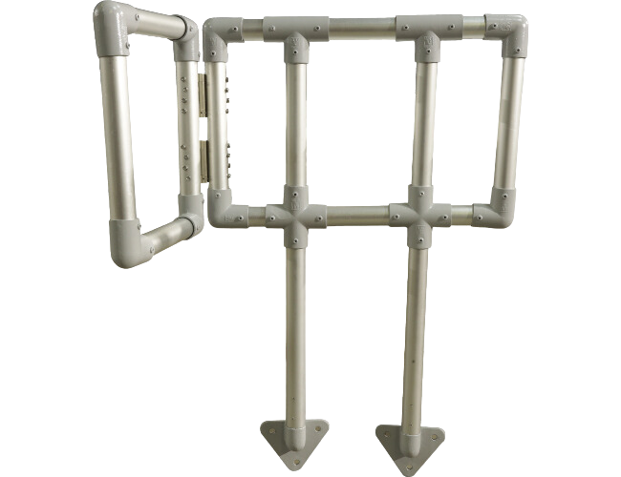

Industrial Safety Systems That Set the Standard
We design and manufacture high-performance aluminum handrail systems for industrial and infrastructure projects where safety is non-negotiable. Engineered for extreme and corrosive environments, our systems deliver long service life, minimal maintenance, and reduced lifecycle cost.
When your project demands proven quality, fast execution, and zero compromise, we deliver.

Premium Aluminum Handrail Systems
Our aluminum handrail systems combine exceptional structural strength with lightweight design, enabling faster installation, lower labor costs, and long-term reliability. Manufactured from premium aluminum alloys, they are the preferred replacement for conventional steel handrails in demanding industrial conditions.

Key Advantages
- Superior corrosion resistance for coastal and industrial environments
- Lightweight construction for rapid installation and reduced site cost
- High impact resistance for maximum personnel safety
- Maintenance-free performance with extended service life
- Clean, professional finish for industrial and architectural applications

Built for the Toughest Applications
Our aluminum handrail systems are trusted across critical sectors, including:
- Sewage and wastewater treatment plants
- RO and desalination facilities
- Marine and coastal installations
- Pumping stations and utility networks
- Power plants and substations
- Metro stations, tunnels, and rail infrastructure
- Airports and transportation hubs
- Heavy industrial and commercial facilities

High-Grade Materials & Finishes
All systems are manufactured using premium aluminum alloys 6060 / 6063 T6 / 6082 T6, selected for strength, durability, and long-term corrosion resistance.
Available Surface Finishes
- Mill Finish
- Anodized Finish
- High-Performance Powder Coated Finish
Each finish is engineered to enhance protection, appearance, and lifecycle performance.

Handrail System Options
Welded Aluminum Handrail System
Heavy-duty strength for critical safety zones
Stanchion-Type Aluminum Handrail System
Flexible configuration with fast and efficient installation
Modular Aluminum Handrail System
Rapid assembly, consistent quality, and easy customization

Why Professionals Choose Us
✔ Engineered for harsh Saudi & GCC environments
✔ Precision manufacturing with strict quality control
✔ Reduced installation time and lifecycle cost
✔ Reliable performance for long-term safety
✔ Trusted partner for industrial and infrastructure projects
We don’t just supply products — we deliver engineered safety solutions.

Your Trusted Partner for Safer Projects
From engineering support to final delivery, we work closely with contractors, consultants, and project owners to ensure on-time execution and dependable performance. Our commitment is simple: build safer projects with uncompromising quality.
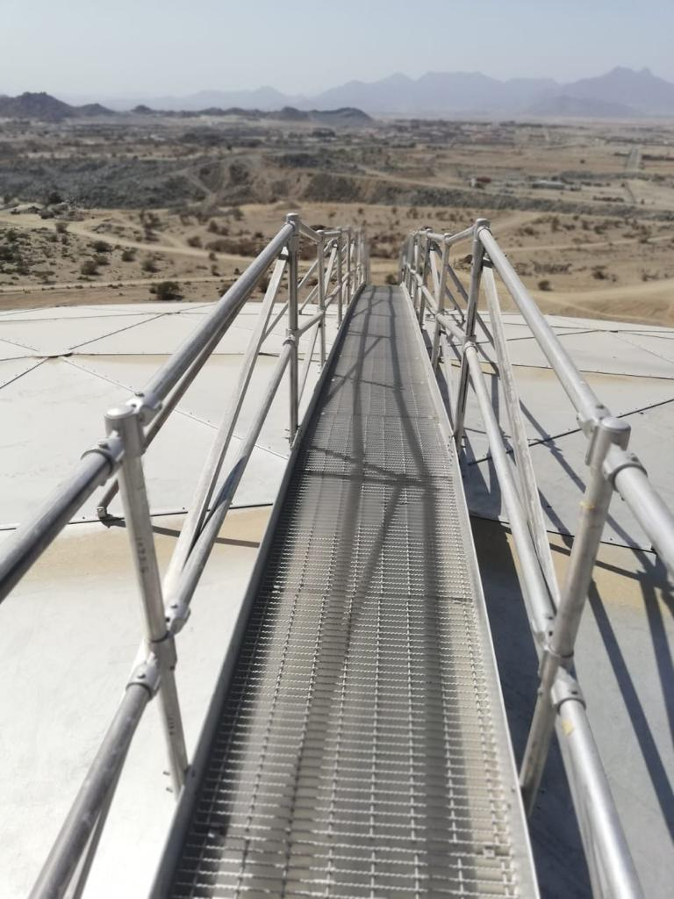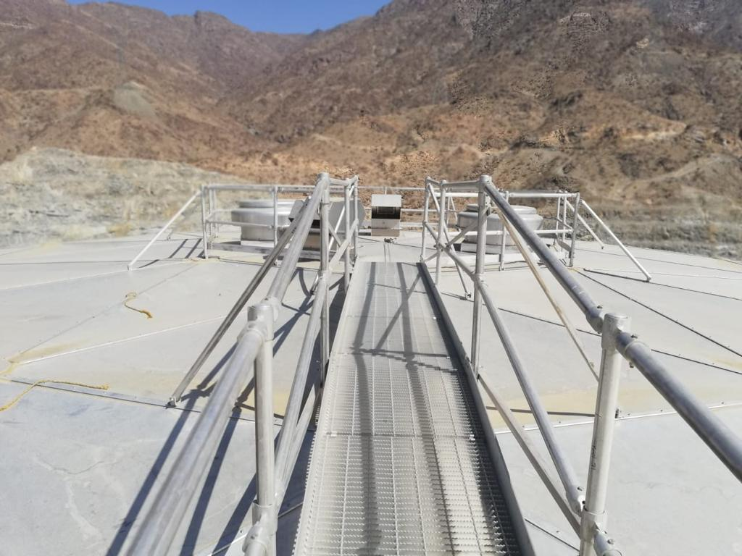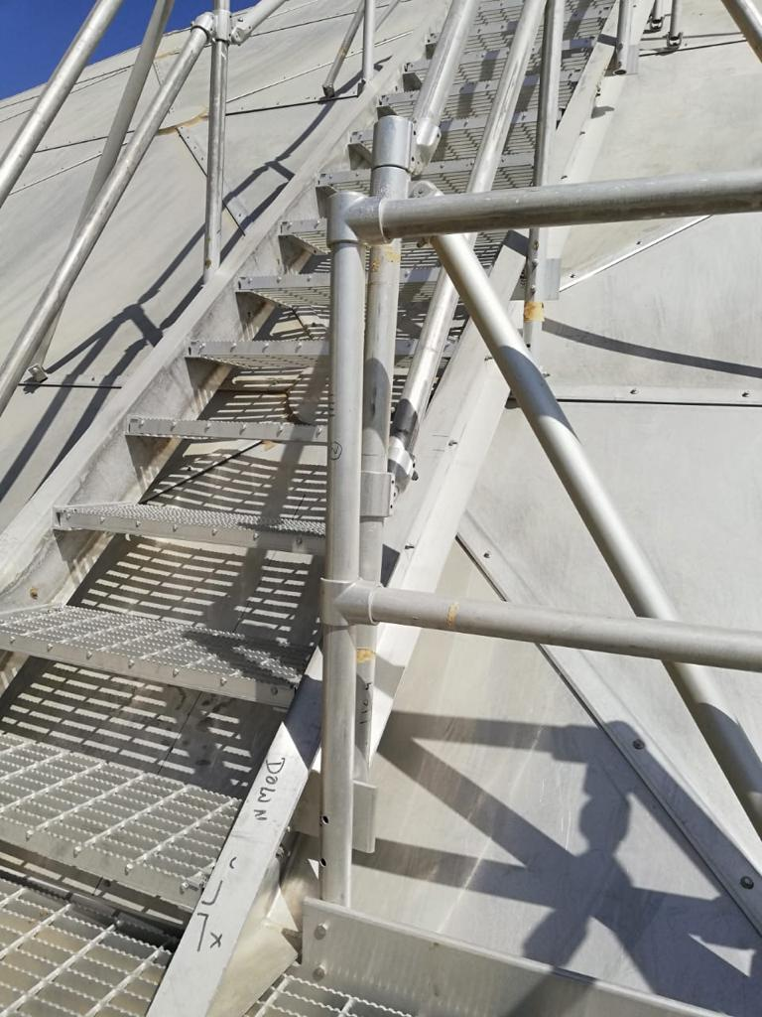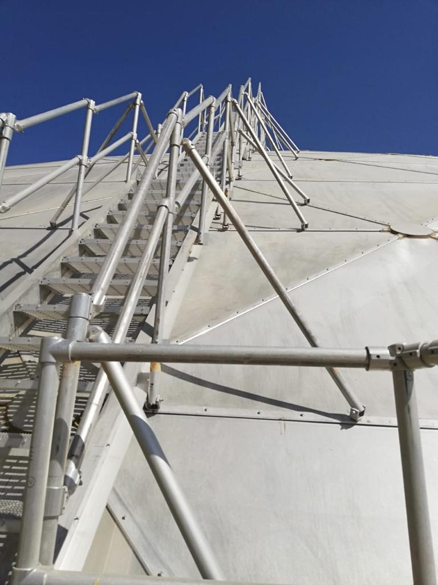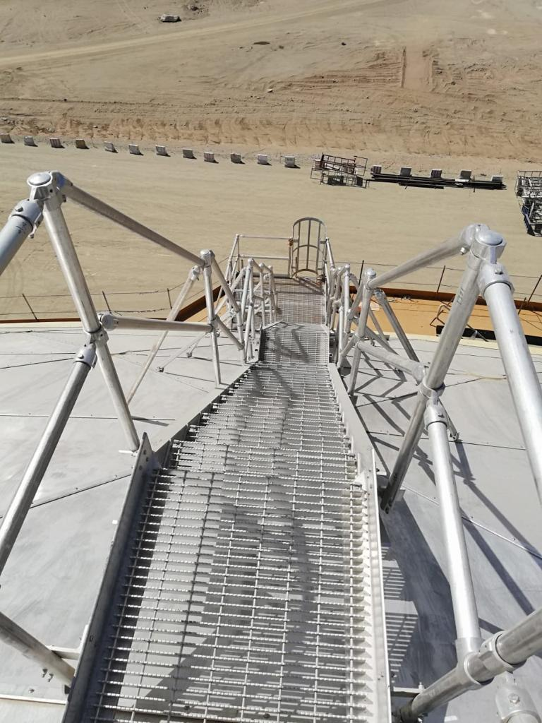

Aluminum Ladder
https://www.ibic.be/app/uploads/dynamic/2020/08/Dropbox_DBS_3319-e1598599483567-1920x511-c-default.jpg

https://www.royalite-mfg.com/wp-content/uploads/2016/01/fixed-cage-ladder-1.jpg
https://elitesafetysystems.co.uk/wp-content/uploads/vert-ladder-03.jpg
https://www.safety-solutions.be/wp-content/uploads/2024/06/ladder4.jpg
https://www.safety-solutions.be/wp-content/uploads/2024/06/ladder5.jpg

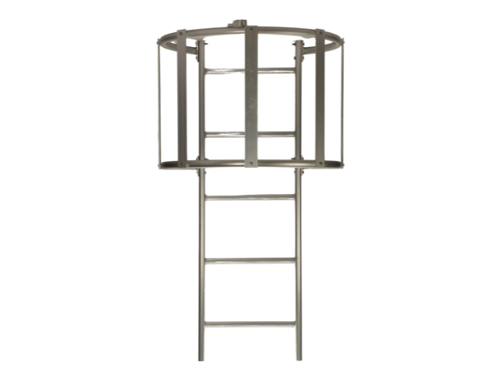

High‑Performance Aluminum Ladders
Our aluminum ladders are engineered to deliver maximum safety, long service life, and low maintenance performance for industrial, commercial, and infrastructure projects. Designed for easy installation and reliable operation, they are the preferred access solution in environments where durability and safety cannot be compromised.
Manufactured from high‑grade aluminum alloys, our ladders combine lightweight construction with excellent corrosion resistance, ensuring dependable performance in both indoor and outdoor applications.

Key Advantages
- Superior corrosion resistance for harsh and coastal environments
- Lightweight design for fast handling and easy installation
- Strong, stable, and safe access solution
- Minimal maintenance with long operational life
- Suitable for continuous industrial and commercial use

Wide Range of Applications
Our aluminum ladders are widely used in:
- High‑rise buildings and commercial complexes
- Shopping malls and educational institutions
- Hospitals and healthcare facilities
- Sewage and wastewater treatment plants
- Chambers, pumping stations, and utility networks
- Power plants and substations
- Metro stations, tunnels, and rail infrastructure
- Airports and transportation facilities
- Industrial plants and process facilities

Material & Surface Finish
- Aluminum Alloys: 6060 / 6063 T6 / 6082 T6
- Available Finishes:
  - Mill Finish
  - High‑performance Powder Coated Finish
Each finish is selected to enhance corrosion protection, appearance, and long‑term durability.

Ladder Types & Specifications
- Aluminum Ladder with Safety Cage
- Aluminum Ladder without Cage
- Aluminum Retractable Ladder
Standard width: 400 mm
Heights & models: Available in multiple configurations
Customized sizes and designs are available to meet project‑specific safety and access requirements.

Designed for Safety. Built for Reliability.
Every aluminum ladder is manufactured under strict quality control to ensure structural strength, dimensional accuracy, and safe performance throughout its service life.

Alumninium Access Cover
https://encrypted-tbn2.gstatic.com/images?q=tbn:ANd9GcRpVoZDjtgjDsiwK7b7GPr1TFgyoYZRdWd9lPa3O7-oVrwEH5Be
https://roofaccesshatches.co.uk/uploads/original/dakluik%20met%20opsteekladder-min.png
https://roofaccesshatches.co.uk/uploads/original/dakluik_met_opsteekladder_staka.jpg

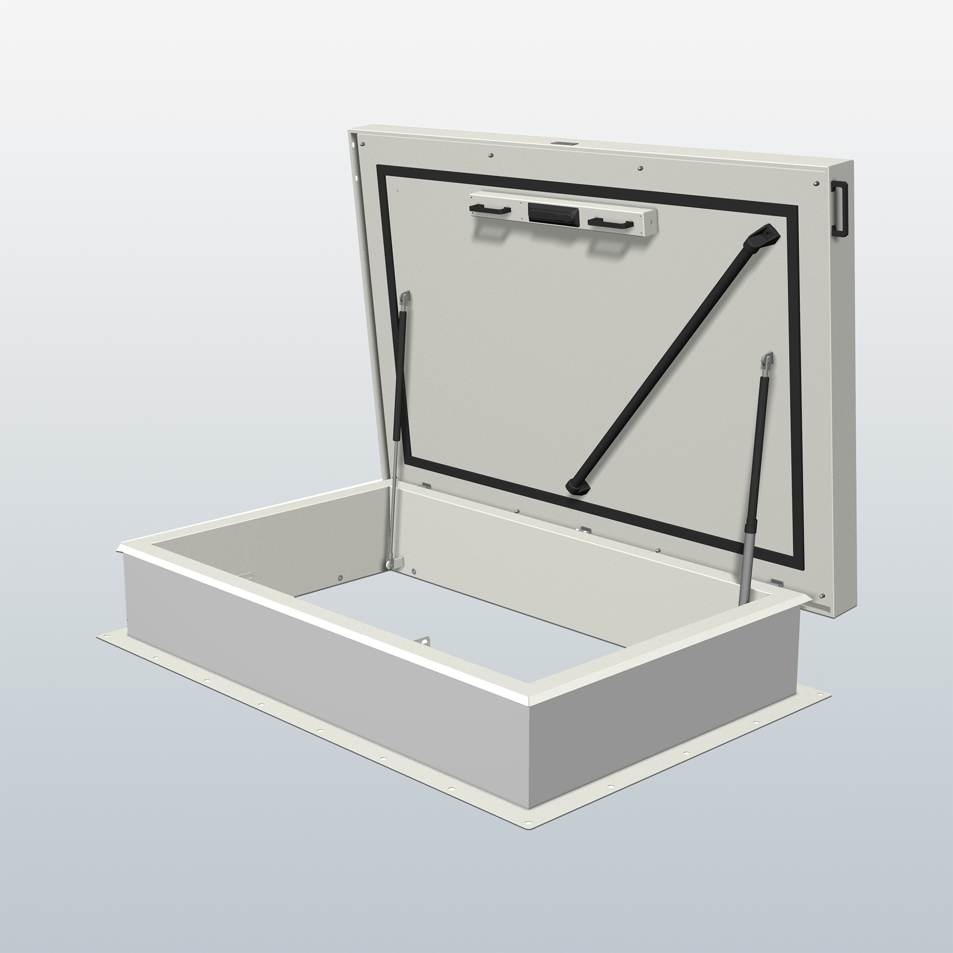

High-Performance Access Hatch Covers
Our access hatch covers are engineered for safety, durability, and long-term performance in roofs, floors, and water tank applications. Designed for easy installation and reliable operation, they are trusted across industrial, commercial, and infrastructure projects.
Available in standard dimensions or custom sizes, our hatch covers provide the perfect solution for every access requirement.

Key Advantages
- Robust construction for long-lasting strength and reliability
- Superior corrosion resistance for harsh environments
- Easy installation with minimal maintenance
- Customizable sizes to suit project-specific needs
- Clean, professional finish for industrial and architectural applications

Types of Hatch Covers
- Roof Type – durable access for rooftops
- Up-Stand Type – elevated frames for structural integration
- Flushed Type – seamless floor integration
- Glazed Type – transparent or semi-transparent access
- Drop-in Type – quick-install and low-maintenance solution

Premium Materials
- Aluminum 6063 – lightweight, strong, corrosion-resistant
- Aluminum 6082 – high-strength alloy for critical applications
- Stainless Steel – robust and maintenance-free for extreme environments

Surface Finishes
- Mill Finish – natural aluminum elegance
- Anodized Finish – superior corrosion protection
- Powder Coated Finish – durable, color-customizable surface
Each finish enhances appearance, durability, and longevity, ensuring your hatch covers remain functional and visually appealing for years.

